# Backpack Flashlight SMD

## Schematic description

This is a construction of backpack flashlight based on SMD components.

The whole construction is based on ATTINY24 microcontroller. It is powered by tiny LiPol accumulator with charging circuit. The circuit is turned on by holding a button for at least 2 seconds. Q2 and Q1 transistors are turned on when button is pressed sourcing microcontroller with power. Microcontroller then activates PWR signal to keep transistors turned on. Button state is signalized by BTN signal that is isolated from the PWR signal by dual Schottky diode D2.

## Construction

Construction has components placed on both sides of the PCB. We start populating USB connector, resistors, then continue with capacitors, diode D2, transistors and LEDs. Finally, we populated ICs and button.

**Note:** LED diodes are in 1206 SMD package. You can use any type. The best are LED diodes with low emitting angle.

## How to get it into service

It should work on the first try when everything is soldered well and microcontroller is programmed.

## Bill of materials

|  |  |  |
| --- | --- | --- |
| **Annotation** | **Value** | **Qty** |
| C1,C2 | 4u7 | 2 |
| D1 | 1206 Red low intensity | 1 |
| D3,D4,D5,D6,D7,D8,D9,D10,D11,D12,D13,D14 | 1206 Red high intensity | 12 |
| D2 | BAS70-06 | 1 |
| J1 | 105017-0001 | 1 |
| J2 | 6pin | 1 |
| Q1 | BSS84 | 1 |
| Q2 | BC848 | 1 |
| R1 | 47k | 1 |
| R2 | 470R | 1 |
| R3 | 2M2 | 1 |
| R4,R5,R6,R19,R20 | 10k | 5 |
| R7,R8,R9,R10,R11,R12,R13,R14,R15,R16,R17,R18 | 220R | 12 |
| SW1 | 6x6 SMD | 1 |
| TP1 | BAT+ | 1 |
| TP2 | BAT- | 1 |
| U1 | MCP73831-2-OT | 1 |
| U2 | ATtiny24-20SS | 1 |

## PCB assembly

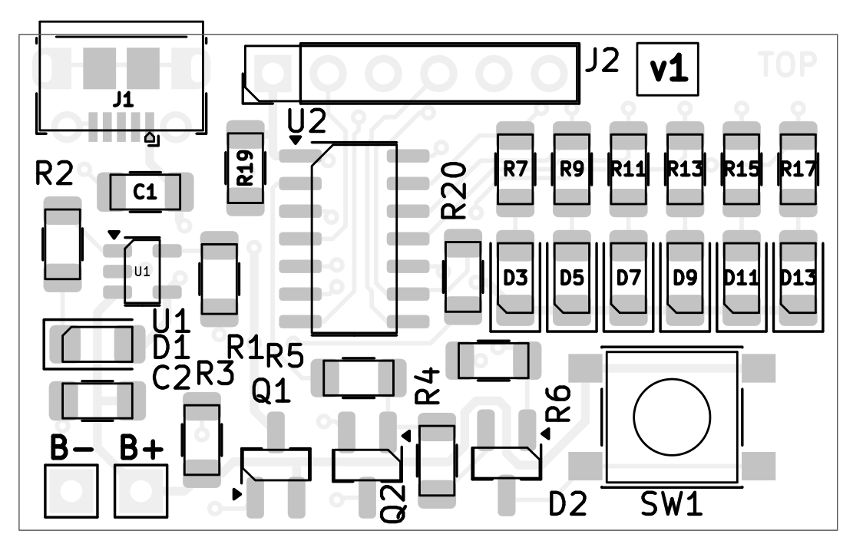

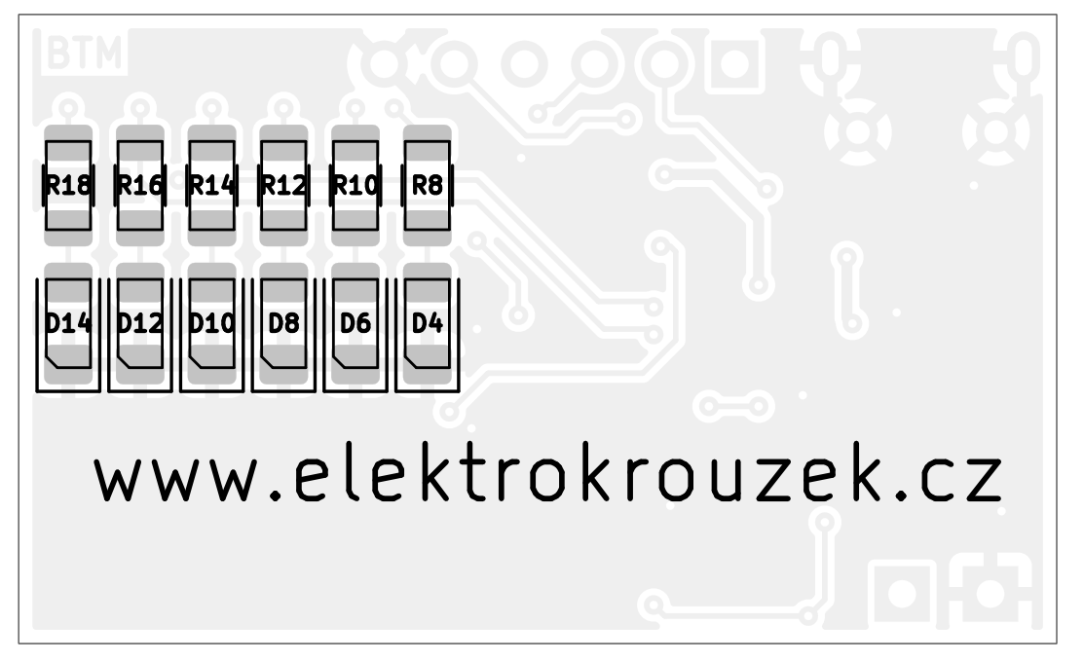

## Microcontroller programming

Several programmers for Atmel AVR can be used for microcontroller programming. We’ve used Asix Presto. Following picture shows connection of Asix Presto to J2 connector (J2 pin numbers are red).

Source code and binary file can be downloaded from club github:

<https://github.com/Elektrokrouzek-cz/backpack-flashlight-smd>

Configuration:

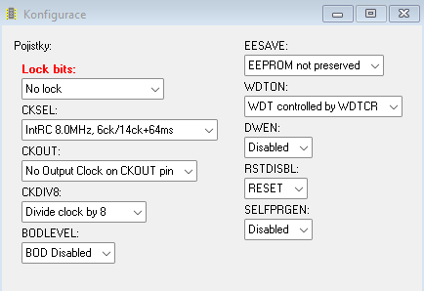

## Mechanical construction

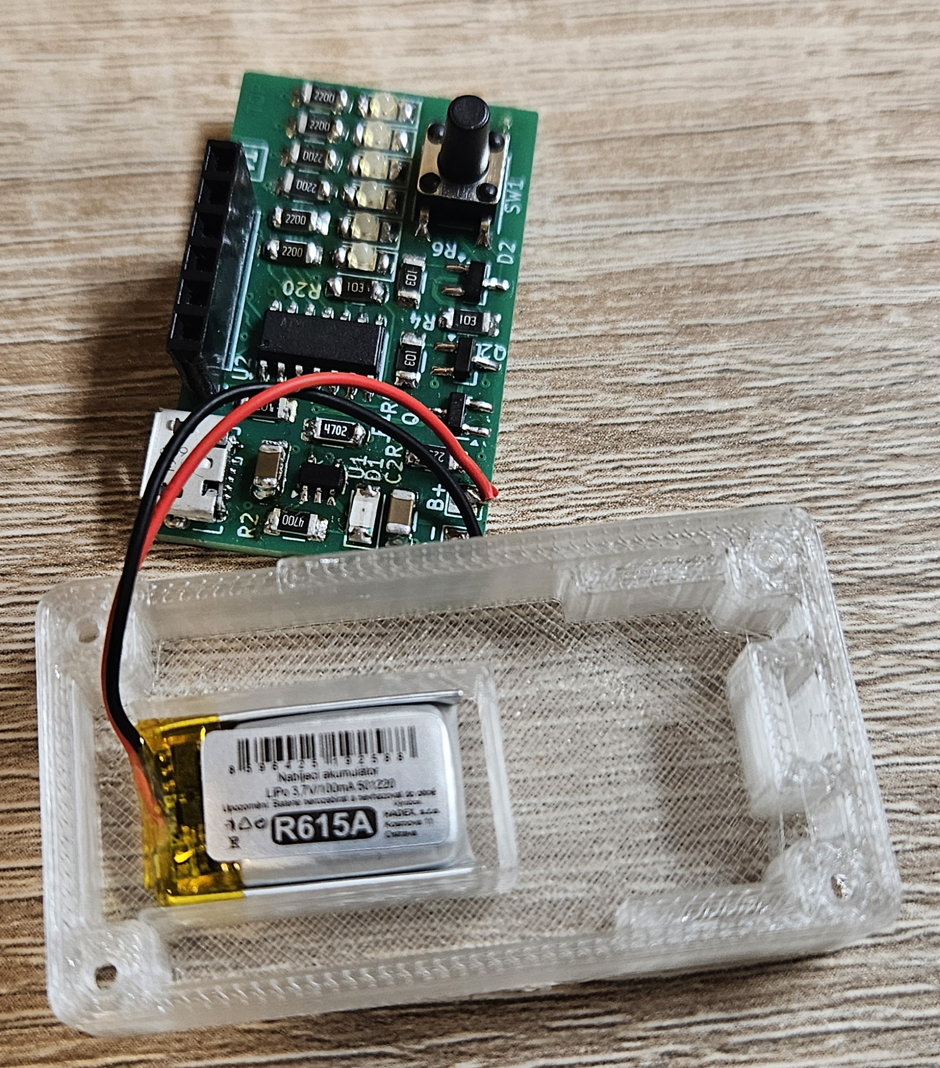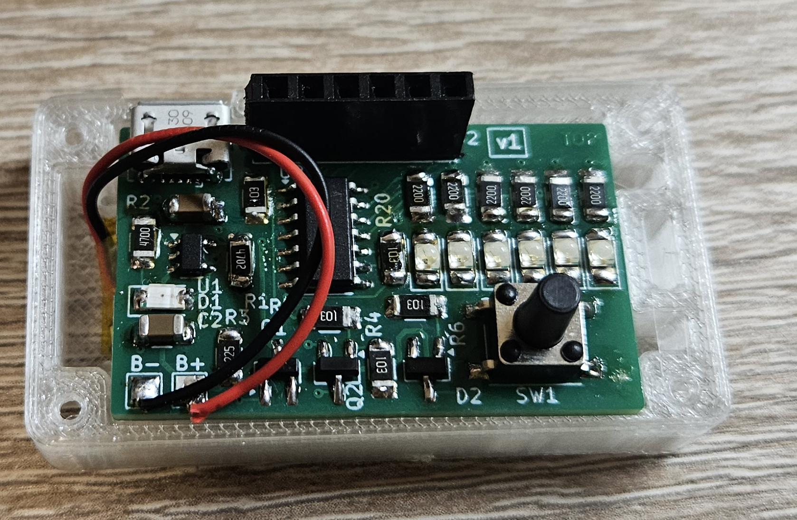

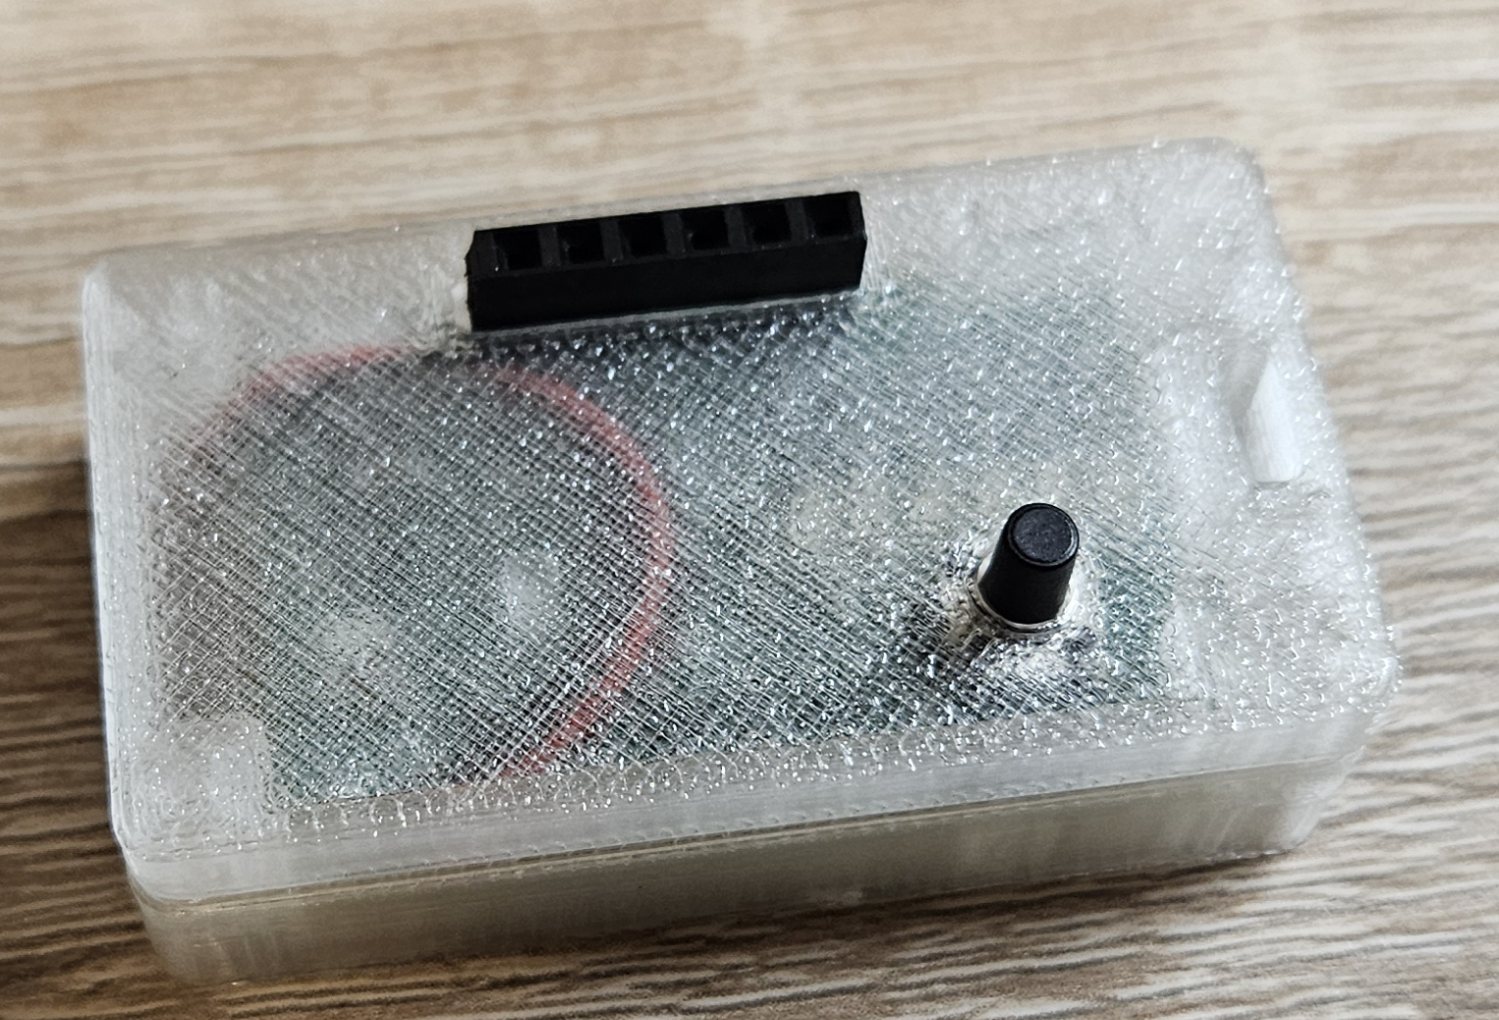

## Schematic

